Technical Specification Form

SAP Routing Details

**Technical specification content**

1. Business Requirement
2. Development Tools
3. Development Objects

* Table.
* CDS Data Definition.
* CDS Access Control.
* SEGW – OData Project.

1. Business API / OData API and Output Screen

SAP Technical Specification Form

|  |  |  |  |
| --- | --- | --- | --- |
| User Story ID # | 9000RUPESH | Module | PP |
| Date | 30.06.2025 | SL User |  |
| Consultant |  | Developer | Debidutta swain |
| Priority | ☐Urgent ☐High ☒Medium ☐Low | | |
| Application Type | ☐Report ☐Form ☐Interface ☒ODATA ☐Others | | |
| Execute Model | ☐Batch ☐ Foreground ☐Manual ☐Quarterly ☐Monthly  ☐Weekly ☐ Daily ☒Real time | | |
| Output Type | ☐Message ☐Dialog Screen ☐ABAP List ☒List View ☐ALV Grid | | |
| Remarks | SAP Routing Data | | |

# 

1. **Business Requirement:**

Develop an OData API for Routing data , through which Business user can check Routing master data in External SAP application .In the External SAP application, user can able to see following details in a List view manner.



**2.Development Status & Tools**

For development these are the following tool used :

* **Eclipse for ABAP /ADT(ABAP Development Tool)**
* Interface/Basic CDS view: Created on top of Required Database.
* Composite CDS view: Created on top of Interface basic view for join/association.
* Consumption view: Expose only those field required for Business Requirement.
* **SEGW OData Project**
* Created OData project with “Data Source Reference” Using the consumption CDS view, generate the Project.
* For Service Registration used Tcode : /O/IWFND/MAINT_SERVICE.
* To Check the final data at Gateway Client used Tcode /O/IWFND/GW_CLIENT.

**3.Development Objects**

* Table:
* **MAPL:** Assignment of Task Lists to Materials
* **PLKO:** Task list – header
* **PLAS:** Task list - selection of operations/activities
* **PLPO:** Task list - operation/activity
* **CDS Data Definition:**
* **Basic CDS View:**

As I am following the VDM modeling in this development, I had created Basic CDS view on top of Database table and The source of Basic View Should be a Datbase View or Standard CDS viw.

* **MAPL: Assignment of Task Lists to Materials**  
  CDS View Name: ZI_PP_AssignmentTaskMaterial
* @AbapCatalog.sqlViewName: 'ZDDL_MAPL'
* @AbapCatalog.compiler.compareFilter: true
* @AbapCatalog.preserveKey: true
* @AccessControl.authorizationCheck: #NOT_REQUIRED
* @EndUserText.label: 'Basic CDS:MAPL:Assignment of Task Lists to Materials'
* @Metadata.ignorePropagatedAnnotations: true
* @VDM.viewType: #BASIC
* @ObjectModel.usageType:
* {
* dataClass: #MASTER,
* sizeCategory: #XL,
* serviceQuality: #A
* }
* **define** **view** ZI_PP_AssignmentTaskMaterial
* **as** **select** **from** mapl
* **{**
* **key** matnr **as** Material**,**
* **key** werks **as** Plant**,**
* **key** plnty **as** TaskListType**,**
* **key** plnnr **as** TaskGroup**,**
* **key** plnal **as** GroupCounter**,**
* loekz **as** DeleteInd**,**
* andat **as** CreatedOn**,**
* annam **as** CreatedBy**,**
* aedat **as** ChangedOn**,**
* aenam **as** ChangedBy
* **}**
* **where**
* loekz **=** ' '
* **and** plnty **=** 'N'
* **PLKO: Task list - header**
* CDS View Name: ZI_PP_TasklistHeader
* @AbapCatalog.sqlViewName: 'ZDDL_PLKO'
* @AbapCatalog.compiler.compareFilter: true
* @AbapCatalog.preserveKey: true
* @AccessControl.authorizationCheck: #NOT_REQUIRED
* @EndUserText.label: 'Basic CDS:PLKO:Task List Header'
* @Metadata.ignorePropagatedAnnotations: true
* @VDM.viewType: #BASIC
* @ObjectModel.usageType:
* {
* dataClass: #MASTER,
* sizeCategory: #XL,
* serviceQuality: #A
* }
* **define** **view** ZI_PP_TasklistHeader
* **as** **select** **from** plko
* **{**
* **key** plnty **as** TaskListType**,**
* **key** plnnr **as** TaskGroup**,**
* **key** plnal **as** GroupCounter**,**
* datuv **as** ValidFrom**,**
* loekz **as** DeleteInd**,**
* andat **as** CreatedOn**,**
* annam **as** CreatedBy**,**
* aedat **as** ChangedOn**,**
* aenam **as** ChangedBy**,**
* valid_to **as** ValidTo
* **}**
* **where** loekz **=** ' '
* **PLAS : Task list - selection of operations/activities**
* CDS View Name: ZI_PP_TaskSelectionOprnActv
* @AbapCatalog.sqlViewName: 'ZDDL_PLAS'
* @AbapCatalog.compiler.compareFilter: true
* @AbapCatalog.preserveKey: true
* @AccessControl.authorizationCheck: #NOT_REQUIRED
* @EndUserText.label: 'Basic CDS:PLAS:Task list-selection of operations/activities'
* @Metadata.ignorePropagatedAnnotations: true
* @VDM.viewType: #BASIC
* @ObjectModel.usageType:
* {
* dataClass: #MASTER,
* sizeCategory: #XL,
* serviceQuality: #A
* }
* **define** **view** ZI_PP_TaskSelectionOprnActv
* **as** **select** **from** plas
* **{**
* **key** plnty **as** TaskListType**,**
* **key** plnnr **as** TaskGroup**,**
* **key** plnal **as** GroupCounter**,**
* **key** plnkn **as** TaskListNode**,**
* datuv **as** ValidFrom**,**
* loekz **as** DeleteInd**,**
* andat **as** CreatedOn**,**
* annam **as** CretedBy**,**
* aedat **as** ChangedOn**,**
* aenam **as** ChangedBy**,**
* valid_to **as** ValidTo
* **}**
* **where** loekz **=** ' '
* **PLPO: Task list - operation/activity**
* CDS View Name: ZI_PP_PLPO_TOP_counter

ZI_PP_TaskListOprnActvFinal

ZI_PP_TaskListOprnActvity

**Note** : Here From PLPO Table I have to consider the Current /New Counter Value Record, so for that scenario, first I filter the Current Counter Record by using “ZI_PP_PLPO_TOP_counter” CDS view, where I am considering the MAX Counter value which is nothing but the Current counter record need to show in report.  
 With that “ZI_PP_PLPO_TOP_counter” CDS I joined the PLKO table to fetch the Required details need for Report. For that I created one CDS View named as “ZI_PP_TaskListOprnActvFinal”.

On top of “ZI_PP_TaskListOprnActvFinal” CDS view I a New CDS view to show the final PLPO Field Details and that CDS view Named as “ZI_PP_TaskListOprnActvity”.

* **PLPO: Task list - operation/activity**
* CDS View Name: ZI_PP_PLPO_TOP_counter
* @AbapCatalog.sqlViewName: 'ZMAXCOUNT'
* @AbapCatalog.compiler.compareFilter: true
* @AbapCatalog.preserveKey: true
* @AccessControl.authorizationCheck: #NOT_REQUIRED
* @EndUserText.label: 'Basic CDS:PLPO:Get the Top/Max Counter Value'
* @Metadata.ignorePropagatedAnnotations: true
* **define** **view** ZI_PP_PLPO_TOP_counter **as** **select** **from** plpo
* **{**
* plnty **as** TaskListType**,**
* plnnr **as** TaskGroup**,**
* plnkn **as** Node**,**
* **max(** zaehl **)** **as** maxCounter
* **}**
* **group** **by**
* plnty**,**
* plnnr**,**
* plnkn
* CDS View Name: ZI_PP_TaskListOprnActvFinal
* @AbapCatalog.sqlViewName: 'ZPLPOFINAL'
* @AbapCatalog.compiler.compareFilter: true
* @AbapCatalog.preserveKey: true
* @AccessControl.authorizationCheck: #NOT_REQUIRED
* @EndUserText.label: 'Basic CDS:PLPO:Task list - operation/activity final'
* @Metadata.ignorePropagatedAnnotations: true
* **define** **view** ZI_PP_TaskListOprnActvFinal
* **as** **select** **from** ZI_PP_PLPO_TOP_counter **as** maxplpo
* **inner** **join** plpo **on** plpo**.**plnty **=** maxplpo**.**TaskListType
* **and** plpo**.**plnnr **=** maxplpo**.**TaskGroup
* **and** plpo**.**plnkn **=** maxplpo**.**Node
* **and** plpo**.**zaehl **=** maxplpo**.**maxCounter
* **{**
* **key** maxplpo**.**TaskListType**,**
* **key** maxplpo**.**TaskGroup**,**
* **key** maxplpo**.**Node**,**
* **key** maxplpo**.**maxCounter **as** Counter**,**
* plpo**.**loekz **as** DeleteInd**,**
* plpo**.**vornr **as** OperationActivityNumber**,**
* plpo**.**steus **as** ControlKey**,**
* plpo**.**arbid **as** ObjectId**,**
* plpo**.**ktsch **as** StandardTextKey**,**
* plpo**.**ltxa1 **as** OperationShortText**,**
* plpo**.**bmsch **as** BaseQauntity**,**
* plpo**.**lar01 **as** ActivityType01**,**
* plpo**.**vge01 **as** StandardValueUnit01**,**
* plpo**.**vgw01 **as** StandardValue01**,**
* plpo**.**lar02 **as** ActivityType02**,**
* plpo**.**vge02 **as** StandardValueUnit02**,**
* plpo**.**vgw02 **as** StandardValue02**,**
* plpo**.**lar03 **as** ActivityType03**,**
* plpo**.**vge03 **as** StandardValueUnit03**,**
* plpo**.**vgw03 **as** StandardValue03**,**
* plpo**.**lar04 **as** ActivityType04**,**
* plpo**.**vge04 **as** StandardValueUnit04**,**
* plpo**.**vgw04 **as** StandardValue04**,**
* plpo**.**lar05 **as** ActivityType05**,**
* plpo**.**vge05 **as** StandardValueUnit05**,**
* plpo**.**vgw05 **as** StandardValue05**,**
* plpo**.**lar06 **as** ActivityType06**,**
* plpo**.**vge06 **as** StandardValueUnit06**,**
* plpo**.**vgw06 **as** StandardValue06
* **}**
* **where** loekz **=** ' '
* CDS View Name: ZI_PP_TaskListOprnActvity
* @AbapCatalog.sqlViewName: 'ZDDLPLPO'
* @AbapCatalog.compiler.compareFilter: true
* @AbapCatalog.preserveKey: true
* @AccessControl.authorizationCheck: #NOT_REQUIRED
* @EndUserText.label: 'Basic CDS:PLPO:Task list - operation/activity'
* @Metadata.ignorePropagatedAnnotations: true
* @VDM.viewType: #BASIC
* **define** **view** ZI_PP_TaskListOprnActvity **as** **select** **from** ZI_PP_TaskListOprnActvFinal
* **{**
* **key** TaskListType**,**
* **key** TaskGroup**,**
* **key** Node**,**
* **key** Counter**,**
* OperationActivityNumber**,**
* ControlKey**,**
* ObjectId**,**
* StandardTextKey**,**
* OperationShortText**,**
* BaseQauntity**,**
* ActivityType01**,**
* StandardValueUnit01**,**
* StandardValue01**,**
* ActivityType02**,**
* StandardValueUnit02**,**
* StandardValue02**,**
* ActivityType03**,**
* StandardValueUnit03**,**
* StandardValue03**,**
* ActivityType04**,**
* StandardValueUnit04**,**
* StandardValue04**,**
* ActivityType05**,**
* StandardValueUnit05**,**
* StandardValue05**,**
* ActivityType06**,**
* StandardValueUnit06**,**
* StandardValue06
* **}**
* **Composite CDS view**

As I am following the VDM modeling in this development, I had created Composite CDS view on top of Basic View where I will do all the necessary Joins/association needed for The Current Business Requirement.  
  
CDS View Name : ZCO_PP_RoutingDetails

* @AbapCatalog.sqlViewName: 'ZCODDLROUTING'
* @AbapCatalog.compiler.compareFilter: true
* @AbapCatalog.preserveKey: true
* @AccessControl.authorizationCheck: #NOT_REQUIRED
* @EndUserText.label: 'Composite CDS View:SAP Routing Details'
* @Metadata.ignorePropagatedAnnotations: true
* **define** **view** ZCO_PP_RoutingDetails
* **as** **select** **from** ZI_PP_AssignmentTaskMaterial **as** mapl
* **left** **outer** **join** makt **on** makt**.**matnr **=** mapl**.**Material
* **and** makt**.**spras **=** **$session.system_language**
* **left** **outer** **join** t001w **on** t001w**.**werks **=** mapl**.**Plant
* **left** **outer** **join** ZI_PP_TasklistHeader **as** plko **on** plko**.**TaskListType **=** mapl**.**TaskListType
* **and** plko**.**TaskGroup **=** mapl**.**TaskGroup
* **and** plko**.**GroupCounter **=** mapl**.**GroupCounter
* **left** **outer** **join** ZI_PP_TaskSelectionOprnActv **as** plas **on** plas**.**TaskListType **=** mapl**.**TaskListType
* **and** plas**.**TaskGroup **=** mapl**.**TaskGroup
* **and** plas**.**GroupCounter **=** mapl**.**GroupCounter
* **left** **outer** **join** ZI_PP_TaskListOprnActvity **as** plpo **on** plpo**.**TaskListType **=** mapl**.**TaskListType
* **and** plpo**.**TaskGroup **=** mapl**.**TaskGroup
* **and** plpo**.**Node **=** plas**.**TaskListNode
* **{**
* **key** mapl**.**Material**,**
* **key** mapl**.**Plant**,**
* **key** mapl**.**TaskListType**,**
* **key** mapl**.**TaskGroup**,**
* **key** mapl**.**GroupCounter**,**
* **key** plpo**.**Counter **as** InternalCounter**,**
* mapl**.**CreatedOn**,**
* makt**.**maktx **as** MaterialText**,**
* t001w**.**name1 **as** PlantName**,**
* plko**.**ValidFrom **as** PlkoValidFrom**,**
* plko**.**ValidTo **as** PlkoValidTo**,**
* plko**.**CreatedBy **as** PlkoCreatedBy**,**
* plko**.**CreatedOn **as** PlkoCreatedOn**,**
* plko**.**ChangedBy **as** PlkoChangedBy**,**
* plko**.**ChangedOn **as** PlkoChangedOn**,**
* plas**.**TaskListNode **as** NumberTaskListNode**,**
* plas**.**ValidFrom **as** PlasValidFrom**,**
* plas**.**ValidTo **as** PlasValidTo**,**
* plas**.**CreatedOn **as** PlasCretedOn**,**
* plas**.**CretedBy **as** PlasCretedBy**,**
* plas**.**ChangedOn **as** PlasChagedOn**,**
* plas**.**ChangedBy **as** PlasChagedBy**,**
* plpo**.**OperationActivityNumber**,**
* plpo**.**ControlKey**,**
* plpo**.**StandardTextKey**,**
* plpo**.**ObjectId**,**
* plpo**.**OperationShortText**,**
* plpo**.**BaseQauntity**,**
* plpo**.**ActivityType01**,**
* plpo**.**StandardValueUnit01**,**
* plpo**.**StandardValue01**,**
* plpo**.**ActivityType02**,**
* plpo**.**StandardValueUnit02**,**
* plpo**.**StandardValue02**,**
* plpo**.**ActivityType03**,**
* plpo**.**StandardValueUnit03**,**
* plpo**.**StandardValue03**,**
* plpo**.**ActivityType04**,**
* plpo**.**StandardValueUnit04**,**
* plpo**.**StandardValue04**,**
* plpo**.**ActivityType05**,**
* plpo**.**StandardValueUnit05**,**
* plpo**.**StandardValue05**,**
* plpo**.**ActivityType06**,**
* plpo**.**StandardValueUnit06**,**
* plpo**.**StandardValue06
* **}**
* **Consumption CDS view**

As I am following the VDM modeling in this development, I had created Consumption CDS view on top of Composite CDS View where I had added all the field which are need to Expose as per the Business Requirment.

CDS View name : ZCO_PP_RoutingDetails

* @AbapCatalog.sqlViewName: 'ZCDDLROUTING'
* @AbapCatalog.compiler.compareFilter: true
* @AbapCatalog.preserveKey: true
* @AccessControl.authorizationCheck: #CHECK
* @EndUserText.label: 'Composite View: Routing Details'
* @Metadata.ignorePropagatedAnnotations: true
* @VDM.viewType: #CONSUMPTION
* **define** **view** ZC_PP_Routing_Details
* **as** **select** **from** ZCO_PP_RoutingDetails
* **{**
* **key** Material**,**
* **key** Plant**,**
* **key** TaskListType**,**
* **key** TaskGroup**,**
* **key** GroupCounter**,**
* **key** InternalCounter**,**
* CreatedOn**,**
* MaterialText**,**
* PlantName**,**
* PlkoValidFrom**,**
* PlkoValidTo**,**
* PlkoCreatedBy**,**
* PlkoCreatedOn**,**
* PlkoChangedBy**,**
* PlkoChangedOn**,**
* NumberTaskListNode**,**
* PlasValidFrom**,**
* PlasValidTo**,**
* PlasCretedOn**,**
* PlasCretedBy**,**
* PlasChagedOn**,**
* PlasChagedBy**,**
* OperationActivityNumber**,**
* ControlKey**,**
* StandardTextKey**,**
* ObjectId**,**
* OperationShortText**,**
* BaseQauntity**,**
* ActivityType01**,**
* StandardValueUnit01**,**
* StandardValue01**,**
* ActivityType02**,**
* StandardValueUnit02**,**
* StandardValue02**,**
* ActivityType03**,**
* StandardValueUnit03**,**
* StandardValue03**,**
* ActivityType04**,**
* StandardValueUnit04**,**
* StandardValue04**,**
* ActivityType05**,**
* StandardValueUnit05**,**
* StandardValue05**,**
* ActivityType06**,**
* StandardValueUnit06**,**
* StandardValue06
* **}**
* **CDS Access Control:**

DCL Used In CDS: ZC_PP_ROUTING_DETAILS

DCL Name: ZDCL_PP_ROUTINGDETAIL

* @EndUserText.label: 'DCL for Fiter Routing Details Based on Auth. Plant'
* @MappingRole: true
* **define** **role** ZDCL_PP_ROUTINGDETAIL **{**
* **grant**
* **select**
* **on**
* ZC_PP_Routing_Details
* **where**
* **(**Plant**)** **=** **aspect** **pfcg_auth(**ZPLANTS**,**WERKS**);**
* **}**

* **SEGW – OData Project.**

Project Name: ZGW_PP_ROUTING_DETAIL

Service Name: ZGW_PP_ROUTING_DETAIL_SRV

Entity Type: ZC_PP_Routing_DetailsType  
Entity set: ZC_PP_Routing_Details

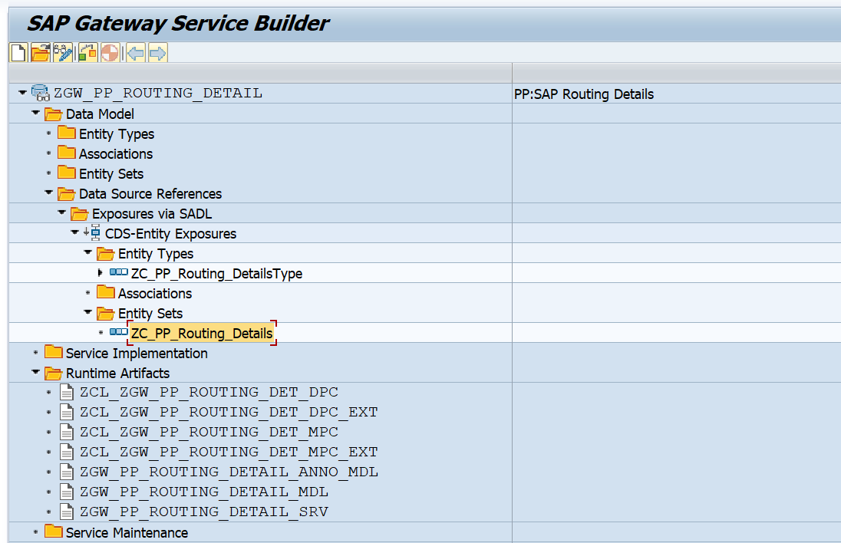Screenshot :

**4.Business API / OData API and Output Screen Screenshot:**

Here filtration is done based on MAPL table’s AEDAT(Created ON) and in the Enity set that field name is also named as **‘CreatedOn’**.  
  
**Tested API with Output Screenshot: :**

Here I have tested with the user where I have authorized to all plant, use this below API pass your parameter for testing(Maybe My Output Scree is Different from your Output Screen.).

**Based on single date Parameter:**

/sap/opu/odata/sap/ZGW_PP_ROUTING_DETAIL_SRV/ZC_PP_Routing_Details?$filter=CreatedOn eq datetime'2023-08-21T00:00:00'

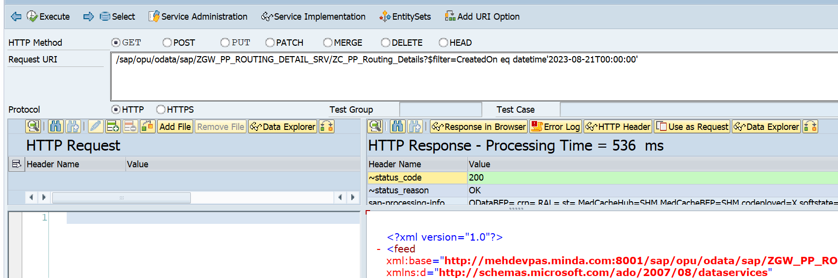

**Count the number of lines for the above API to compare with CDS Fetched record:** /sap/opu/odata/sap/ZGW_PP_ROUTING_DETAIL_SRV/ZC_PP_Routing_Details/$count/?$filter=CreatedOn eq datetime'2023-08-21T00:00:00'

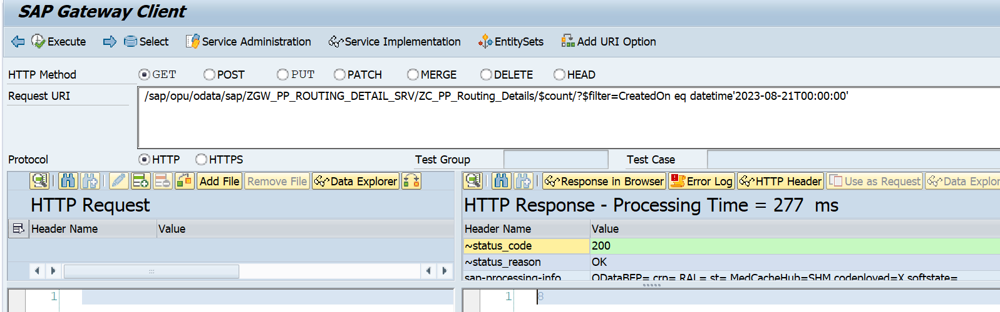

CDS View :

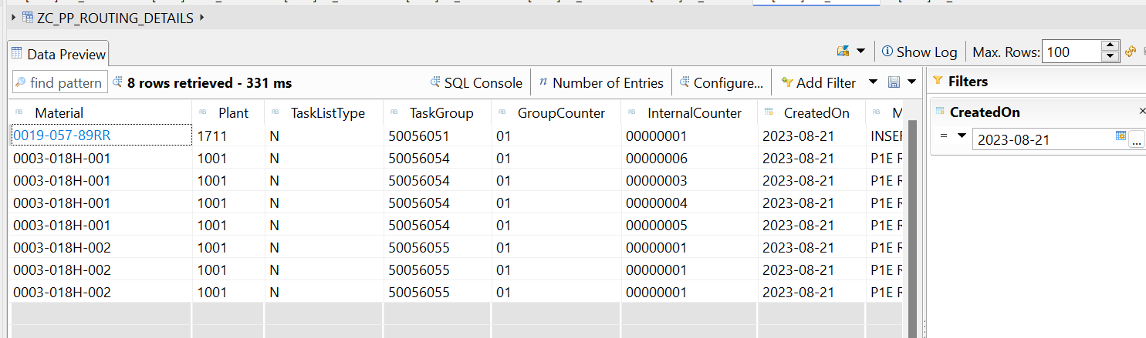

**Based On Select Option/Range:**

**/sap/opu/odata/sap/ZGW_PP_ROUTING_DETAIL_SRV/ZC_PP_Routing_Details?$filter=CreatedOn ge datetime'2018-02-12T00:00:00' and CreatedOn le datetime'2018-02-15T00:00:00'**

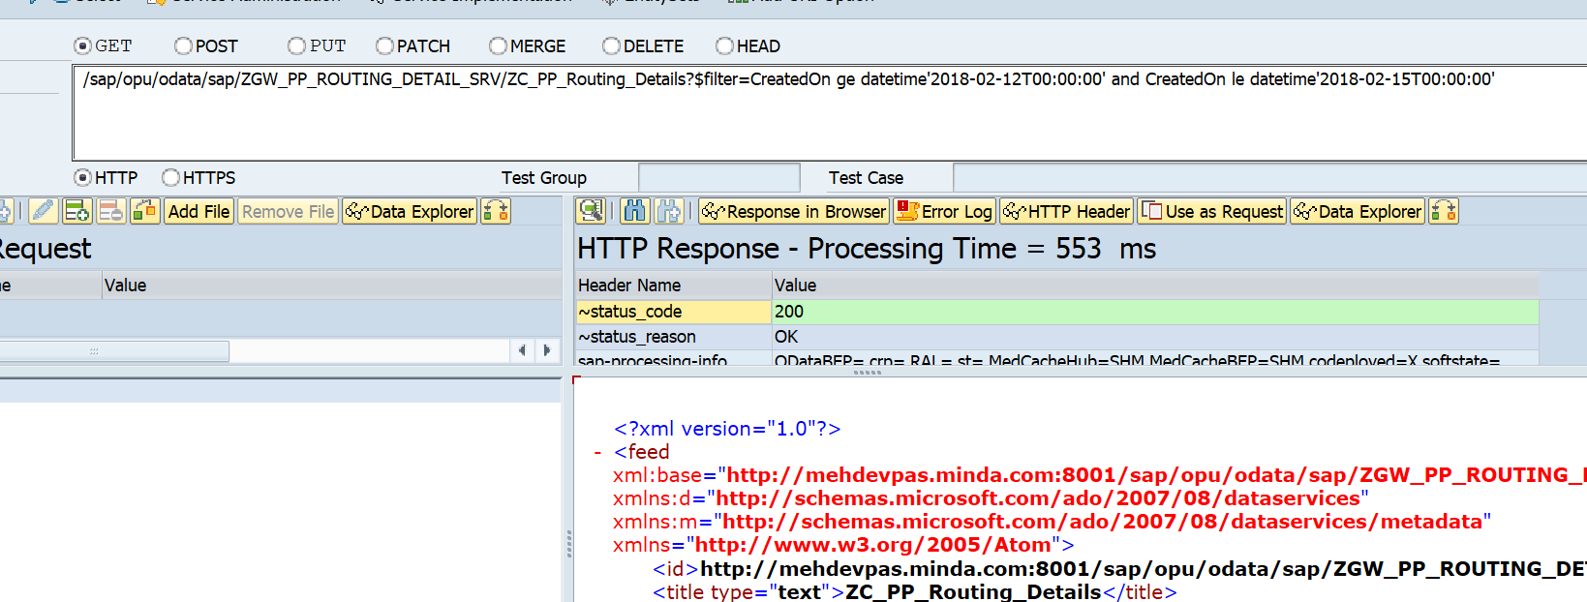

**Count the number of lines for the above API to compare with CDS Fetched record:**

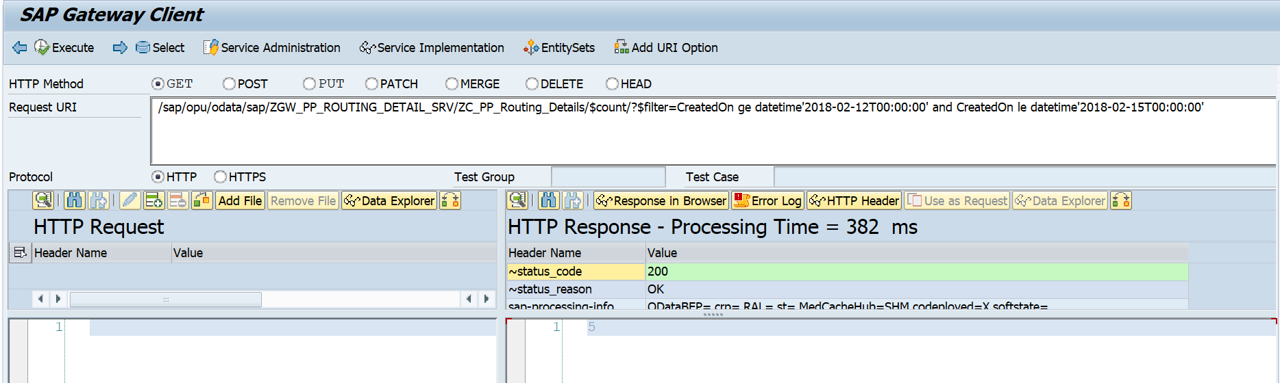

**CDS View Output:**

